TEACHER REFRESHER TRAINING GUIDE
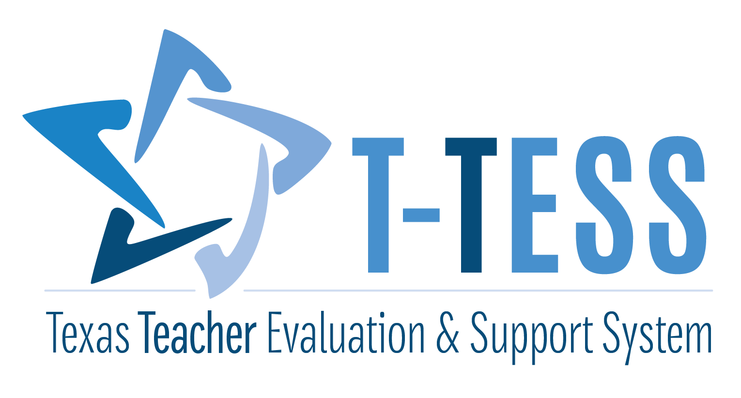

Teacher Refresher Training Guide

Reflection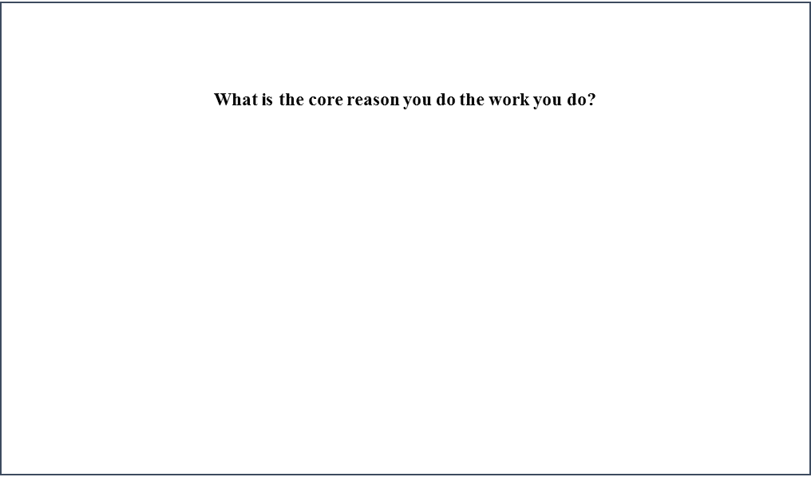

T-TESS Triangle: An Expanded View
The T-TESS process is reflected in the T-TESS Triangle and emphasized as the focus for the classroom observation. The new refresher training for appraisers provides an expanded view of this graphic to illustrate how several purposeful triangles are layered to depict the bigger picture representation.
Layer 1: The basis for teaching and learning begins with the “iron triangle” – curriculum, instruction, and assessment. Driving questions for this triangle are, “What am I going to teach? How and I going to teach? How will I assess learning?” – represented in each segment below.
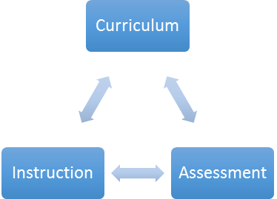
Layer 2: This next layer adds a new dimension to the planning process to connect the content (curriculum), process (instruction) and context (connected to real life in a way that is relevant and useful to students).
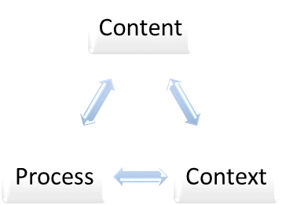
How will this be taught to address individual needs, and interests? Which instructional strategies have a high probability of impacting student performance?
How will information be presented in familiar contexts and those in which the content is relevant and useful? How will it make sense to students in their own frame of reference?
What do I want students to know and be able to do as a result of this lesson? Which curriculum standards will be addressed?

Layer 3: This layer of the triangle represents the planning that occurs prior to the lesson being executed. During the pre-conference, the appraiser and teacher mutually discuss what the teacher “planned” in order to clarify and perhaps refine the planning process in anticipation of the actual lesson. At a minimum, the three questions below are discussed.
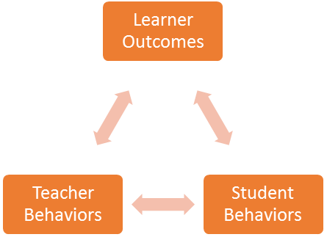
What should the students know and be able to do by the end of the lesson?

How will the teacher know that students have mastered the objective(s)?

What will the teacher and students be doing to show progress toward mastery of the objective(s)?

Layer 4: During the actual lesson, the appraiser anchors the observation in the T-TESS Triangle and captures evidence through strategically scripted notes. The observation begins with the identified learner outcomes and ends with evidence that supports the degree to which students move towards mastery of these outcomes. The appraiser uses the triangle in Layer 3 to connect what was planned to the impact on student learning during the execution of the lesson.
The appraiser is listening for the ‘Learner Outcomes’ or lesson objectives as the anchor for the appraisal.
The appraiser is also collecting evidence regarding what students say and do throughout the lesson using the learner outcomes as a filter for how students are ‘behaving’ and responding to instruction.
Ultimately, the evidence is reviewed to determine whether or not students are meeting the learner outcomes.
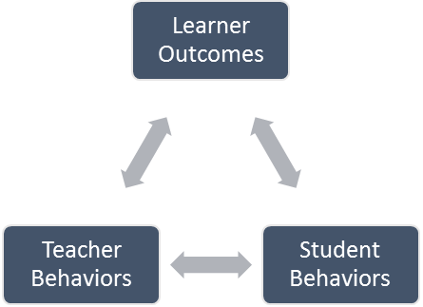
Throughout the lesson – beginning, middle and end – the appraiser is collecting evidence regarding the teacher behaviors and how they are aligned to and support mastery of the identified learner outcomes.

Layer 5: Following the lesson, the appraiser and teacher meet for the post-conference to discuss the lesson, including the areas of reinforcement, refinement, and lesson ratings. The previous layers provide the basis for the post-conference, particularly Layers 3 and 4.
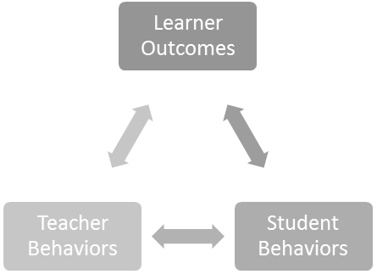
The post-conference reflection is an analysis of the planned and executed lesson using the learner outcomes as the basis for discussions. To what degree did students master the learner outcomes? Why? Why not?
From Analysis to Action:
What occurred during the lesson?
What was the teacher saying and doing?
What were students saying and doing?
What was the cause and effect relationship between teacher and student behaviors?
What does the evidence reflect regarding the strength of the lesson (reinforcement) and area for growth (refinement)?
What are the recommendations for refinement? How will these recommendations be implemented?
What will success look like for the refinement area?
Which resources and support systems are needed? How will they be provided?
What are the next steps?
How will follow-up occur?
Note: The layers are repeated in a cyclical, continuous improvement process throughout the year. Conversations are amplified when teachers meet with appraisers. The ultimate goal is for all teachers to become reflective practitioners where analysis, reflection, and application of practices are self-directed and ongoing.

POP Cycle – Pre-conference, Observation, Post-conference
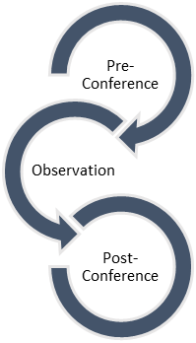
“What are the most impactful aspects of this cycle? Why?”
What do you still need from this system to continue refining your professional craft?
Teacher Outcomes:
To fully understand what teacher and student behaviors ‘look and sound like’ at the proficient, accomplished and distinguished levels as a means of developing highly-effective practices and performance levels over time.

As a campus, what are the next steps to deepen our understanding of the rubric and its application, along with the connections to the Teacher Standards?
To what degree are we able to articulate what the behaviors look like when they are ‘student-centered’ in the accomplished and distinguished levels?

T-TESS Crosswalk
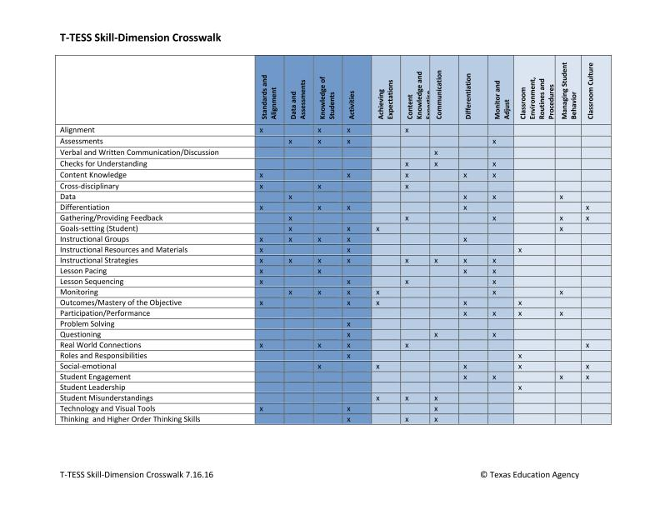

Post-Conferences
“How are you personally addressing your refinement areas?”

“True North”
- What processes should we implement to deepen our understanding with the rubric and correlating practices?
- How are areas of reinforcement and refinement threaded with other aspects of the work and development?
- How might team meeting agendas be more directly connected to the T-TESS rubric and process?
- How should professional development be further linked to individual and collective areas of growth?

Goal Setting and Professional Development Plan
Think about your goals which were established at the end-of-year conference.
In what ways will these goals enhance/hone your knowledge and skills this year?
How will the goals impact student achievement?
Are there any necessary revisions/changes?
How will you maximize professional development to further refine your practices?

